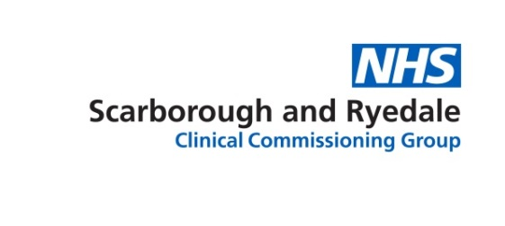
Job Risk Profile
 |  | Details of Risk Level
This role involves: | Yes |  | No | Rare | Occasional | Frequent | Examples
Lifting Weights / objects between 6 – 15 kilos
Lifting weights / objects above 15 kilos
Using equipment to lift, push or pull patients / objects
Lifting heavy containers or equipment
Running in an emergency

Driving alone / with passengers / with goods
Invasive surgical procedures

Working at height

Concentration to assess patients / analyse information
Response to emergency situations

To change plans and appointments / meetings depending on the needs of the role
Clinical Interventions

Informing patients / family / carers of unwelcome news
Caring for terminally ill patients

